Software Design - Assignment 3  
Abhishek Rao(ASU ID: 1210425135)

The submission (CRUD-GradeBook-arao23) contains two projects and a Readme file. The two projects include :

* HATEOAS-GradeBook-arao23srv: Server application developed in REST.
* HATEOAS -GradeBook-arao23cli: JForm application developed in swing.

**Build and Run Instructions:**

* Server Application:
  + - 1. Load the projectHATEOAS **-GradeBook-arao23-srv** in Netbeans 8.2 IDE.
      2. Build and run the project on Glassfish 4.1.1 server
      3. You will see a message “**server started** ” on  [http://localhost:8080/HATEOAS-GradeBook-arao23srv](%20http://localhost:8080/HATEOAS-GradeBook-arao23srv%20)  once the Server starts running.
* Client Application :
  + - 1. Load the project HATEOAS -GradeBook-arao23-cli in Netbeans 8.2 IDE.
      2. Select Main Class as MainScreenUI and click on run application.
      3. Select whether you want to use Professor or student.
      4. Professor can perform CRUD operations on gradeItems and Students can only read the gradeitem and can put appeal if they want the professor to change the marks.

1. **STATE TRANSITION DIAGRAM**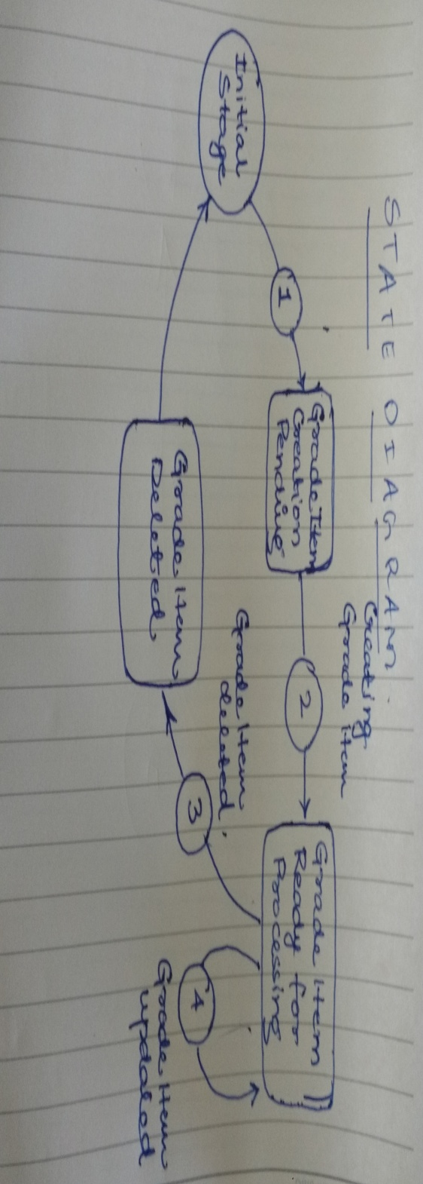
2. **Available States for All operations:**

In this Project we allow 4 state transitions for a resource :

**CREATE**

* Once the professor creates the grade using Create, he can either **Read** the grades, or **Update** the grades or **Delete** the grades. So, once Create operation is done ,Read Update and Delete links are displayed to the user.

**READ**

* If the professor tries to read the grade, he can read the grades and no other links are available to the user except **Self**.

**UPDATE**

* If the professor updates the grade, he has an option of **Read** the grade again, or **Update** the grade or **Delete** the grade.

**DELETE**

* If the professor deletes the grade, he has an option of creating the grade again and no other is available to him.

**CREATE :**

This method creates the gradeitem for a particular student.

**URI :** [http://localhost:8080/HATEOAS-GradeBook-arao23-srv/webapi/webresources/grades/{Student_Id}](http://localhost:8080/HATEOAS-GradeBook-arao23-srv/webapi/webresources/grades/%7bStudent_Id%7d)

**Body of the Request:**

<?xml version="1.0" encoding="UTF-8" standalone="yes"?>

< GradeItem >

<gradeItemName>Midterm</gradeItemName>

<percentageAllocation>48</percentageAllocation>

<marksObtained></marksObtained>

<feedback></feedback>

</ GradeItem >

**Response Codes** : CREATED for successful response, BAD_REQUEST for error in Input payload, INTERNAL_SERVER_ERROR for error in the server, CONFLICT if the resource is already present in the database.

**Available Links for the User to perform**:

* SELF – (CREATE) -- [http://localhost:8080/HATEOAS-GradeBook-arao23-srv/webapi/webresources/grades/{Student_Id}](http://localhost:8080/HATEOAS-GradeBook-arao23-srv/webapi/webresources/grades/%7bStudent_Id%7d)
* GET--[http://localhost:8080/HATEOAS-GradeBook-arao23-srv/webapi/webresources/grades/{Student_Id}/{GradeItem_name}](http://localhost:8080/HATEOAS-GradeBook-arao23-srv/webapi/webresources/grades/%7bStudent_Id%7d/%7bGradeItem_name%7d)
* UPDATE -- [http://localhost:8080/HATEOAS-GradeBook-arao23-srv/webapi/webresources/grades/{Student_Id}/](http://localhost:8080/HATEOAS-GradeBook-arao23-srv/webapi/webresources/grades/%7bStudent_Id%7d/)
* DELETE -- [http://localhost:8080/HATEOAS-GradeBook-arao23-srv/webapi/webresources/grades/{Student_Id}/{GradeItem_name}](http://localhost:8080/HATEOAS-GradeBook-arao23-srv/webapi/webresources/grades/%7bStudent_Id%7d/%7bGradeItem_name%7d)
* **READ**

This method is used to read the gradeitems of a particular student in the database.

**URI** : [http://localhost:8080/HATEOAS-GradeBook-arao23-srv/webapi/webresources/grades/{Student_Id}/{GradeItem_name}](http://localhost:8080/HATEOAS-GradeBook-arao23-srv/webapi/webresources/grades/%7bStudent_Id%7d/%7bGradeItem_name%7d)

**Response Codes** : OK for successful response, NOT_FOUND if there is no student ID found in the database, BAD_REQUEST for for Invalid student ID ,GONE if there is no gradeitems for a particular student

* **Available Links for the User to perform :** SELF – [http://localhost:8080/HATEOAS-GradeBook-arao23-srv/webapi/webresources/grades/{Student_Id}](http://localhost:8080/HATEOAS-GradeBook-arao23-srv/webapi/webresources/grades/%7bStudent_Id%7d)
* **UDATE :**

This method updates the gradeitem for a particular student.

**URI** : [http://localhost:8080/HATEOAS-GradeBook-arao23-srv/webapi/webresources/grades/{Student_Id}/](http://localhost:8080/HATEOAS-GradeBook-arao23-srv/webapi/webresources/grades/%7bStudent_Id%7d/)

**Body of the Request:**

<?xml version="1.0" encoding="UTF-8" standalone="yes"?>

< GradeItem >

<gradeItemName>Midterm</gradeItemName>

<percentageAllocation>48</percentageAllocation>

<marksObtained>45</marksObtained>

<feedback>can do better</feedback>

</ GradeItem >

**Response Codes** : OK for successful response, BAD_REQUEST for error in Input payload, INTERNAL_SERVER_ERROR for error in the server, CONFLICT if the resource is not present in the database

**Available Links for the User to perform**:

* SELF – (UPDATE) -- [http://localhost:8080/HATEOAS-GradeBook-arao23-srv/webapi/webresources/grades/{Student_Id}](http://localhost:8080/HATEOAS-GradeBook-arao23-srv/webapi/webresources/grades/%7bStudent_Id%7d)
* GET--[http://localhost:8080/HATEOAS-GradeBook-arao23-srv/webapi/webresources/grades/{Student_Id}/{GradeItem_name}](http://localhost:8080/HATEOAS-GradeBook-arao23-srv/webapi/webresources/grades/%7bStudent_Id%7d/%7bGradeItem_name%7d)
* DELETE -- [http://localhost:8080/HATEOAS-GradeBook-arao23-srv/webapi/webresources/grades/{Student_Id}/{GradeItem_name}](http://localhost:8080/HATEOAS-GradeBook-arao23-srv/webapi/webresources/grades/%7bStudent_Id%7d/%7bGradeItem_name%7d)
* **Delete**

This method is used to delete the gradeitems for a particular student in the database.

**URI** : [http://localhost:8080/HATEOAS-GradeBook-arao23-srv/webapi/webresources/grades/{Student_Id}/{GradeItem_name}](http://localhost:8080/HATEOAS-GradeBook-arao23-srv/webapi/webresources/grades/%7bStudent_Id%7d/%7bGradeItem_name%7d)

**Response Codes** : OK for successful deletion , NOT_FOUND if the gradeitem is not found, BAD_REQUEST for invalid gradeitem, , INTERNAL SERVER_ERR for for error in the server.

**Available Links for the User to perform**:

* CREATE -- [http://localhost:8080/HATEOAS-GradeBook-arao23-srv/webapi/webresources/grades/{Student_Id}/](http://localhost:8080/HATEOAS-GradeBook-arao23-srv/webapi/webresources/grades/%7bStudent_Id%7d/)

**Important :**

**If you are facing in running the client , Please add this Absolute layout dependency in pom.xml .** This dependency has some issue with Netbeans version.

Kindly check for POM.XML and add this dependency :

**<**dependency>

<groupId>unknown.binary</groupId>

<artifactId>AbsoluteLayout</artifactId>

<version>SNAPSHOT</version>

<type>jar</type> </dependency>

**Also, if there is an issue in running the code on Netbeans 8.1 , please add this dependency code in the pom.xml .** This dependency has some issue with Netbeans version.

**<dependency>**

**<groupId>org.glassfish.jersey.containers</groupId>**

**<artifactId>jersey-container-servlet-core</artifactId>**

**<!-- use the following artifactId if you don't need servlet 2.x compatibility -->**

**<!-- artifactId>jersey-container-servlet</artifactId -->**

**<version>2.17</version>**

**</dependency>**